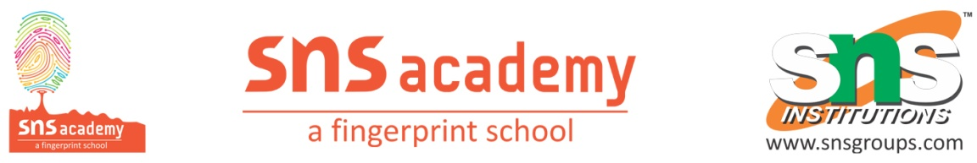

**YEAR PLAN- 2025-2026**

**GRADE: 12 SUBJECT: CHEMISTRY**

|  |  |
| --- | --- |
| **MONTH** | **TOPIC** |
| MARCH | 6. Haloalkanes and arenes |
| APRIL | 7. Alcohols, Phenols and Ethers 1. Solutions |
| JUNE | 8. Aldehydes, Ketones and Carboxylic acids 9. Biomolecules |
| JULY | 2. Electrochemistry 3. Chemical Kinetics |
| AUGUST | 4. Coordination Compounds 5. d and f Block Elements |
| SEPTEMBER | Revision and Quarterly Examination |
| OCTOBER | Revision and First Split Examination |
| NOVEMBER | Revision and Second Split Examination |
| DECEMBER | Revision and model Examinations |
| JANUARY | Mock Practical and Practical Examination |
| FEBRUARY | Board Examination |

Teacher In charge Principal